**SCHOOL SUPPLIES**

**GRADE 2 FRENCH IMMERSION NORTHROP FRYE SCHOOL**

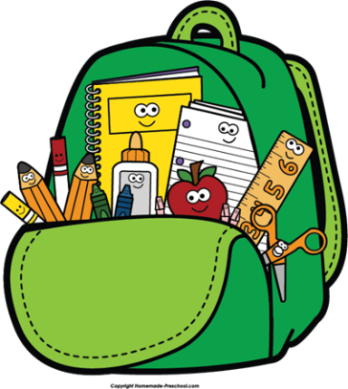

**Please do not label the following:**

2 large white erasers

3 large glue sticks

1 package of 24 crayons (preferably Crayola)

1 package 24 pencil crayons

1 package of 8 Original markers (preferably Crayola)

8 (thin) black dry erase markers

20 HB#2 pencils

10 duo-tangs 2 red, 2 orange, 2 yellow, 2 blue, 2 green (plain colors; not folders)

1 pencil box

2 exercise books – half plain and half interlined (green cover; preferably Hilroy)

1 package of construction paper (multi-colored)

20 plastic page protectors

2 boxes of tissues

1 pair headphones (earbuds not recommended for children), will be returned at the end of the year.

**Please label the following with your child’s name:**

1 courier bag (available at Dollar Stores)

1 pair of scissors

7 $ agenda fee

**Other personal items:**

Gym shoes (non-marking soles and Velcro if child cannot tie shoes)

Lunch box

School bag

A change of clothes in a large sealable bag with their name on it.