**Northrop Frye School**

**Kindergarten School Supplies List 2023**

* **$50.00 for classroom supplies and agenda**

(Supplies will be purchased for your child from the District approved list.)

* 1 large book bag

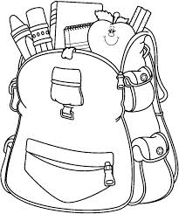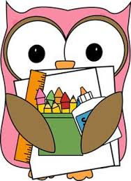

* 1 lunch box
* 2 boxes of tissues
* 1 pair of Velcro or slip-on sneakers for indoors to stay at school.

**(velcro only please – no shoes with laces)**

* 1 change of clothing to be kept at school.

**(Please put them in a large zip lock bag with your child`s name on the bag.)**

**Please label all of the above items with your child`s name.**

**Payment:**

Please pay using School Cash on our school’s website <http://northropfrye.nbed.nb.ca/>.

School cash is already set up for the kindergarten school fee. Please pay before the first day of school. (Directions on how to access School Cash is on the back of this page.)